Created on 2/28/23 by Brad Jensen

Not Being Able to Join a Meeting:
If you are trying to join a meeting and it is not loading it properly there are some steps you can try to resolve this issue.

Have Zoom Desktop App Installed:
- Make sure you have the Zoom desktop app installed instead of just opening a temporary session through a weblink.
  - You can see if you have zoom installed by either hitting the key with the windows logo on it on your keyboard 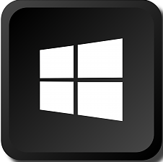, or you can click the windows icon on the left side of your taskbar. (Bottom left corner of the screen) From there, you can type in “Zoom” in the search box, if no Zoom app comes up as a result, you likely do not have it installed.

  - To get the Zoom Desktop Client app you can go to https://zoom.us/download via a web-browser and click the first Download button on the page:
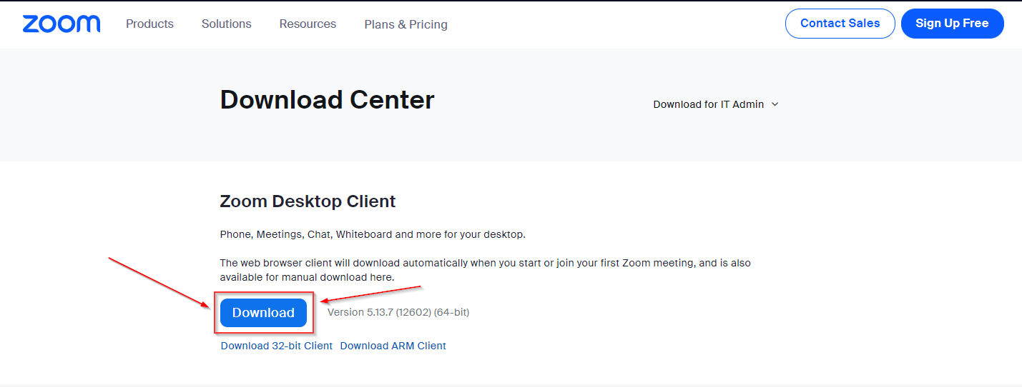

  - Once the file is downloaded you can click on the file it downloaded to run it. (If your browser does not have a pop-up to run the downloaded file, you should be able to find it in your computer’s downloads folder.) When installing it you should be able to just click OK to any prompts and don’t have to change any settings off of the default.

  - You may have to make a free zoom account if you do not already have one to sign into the zoom app.

  - Once you have zoom installed, you can try opening the meeting link again to see if it works.
Update The Zoom App:

- If you already have the zoom app you can try to update the app by clicking on the profile picture at the top right of the app window and selecting “Check for Updates”
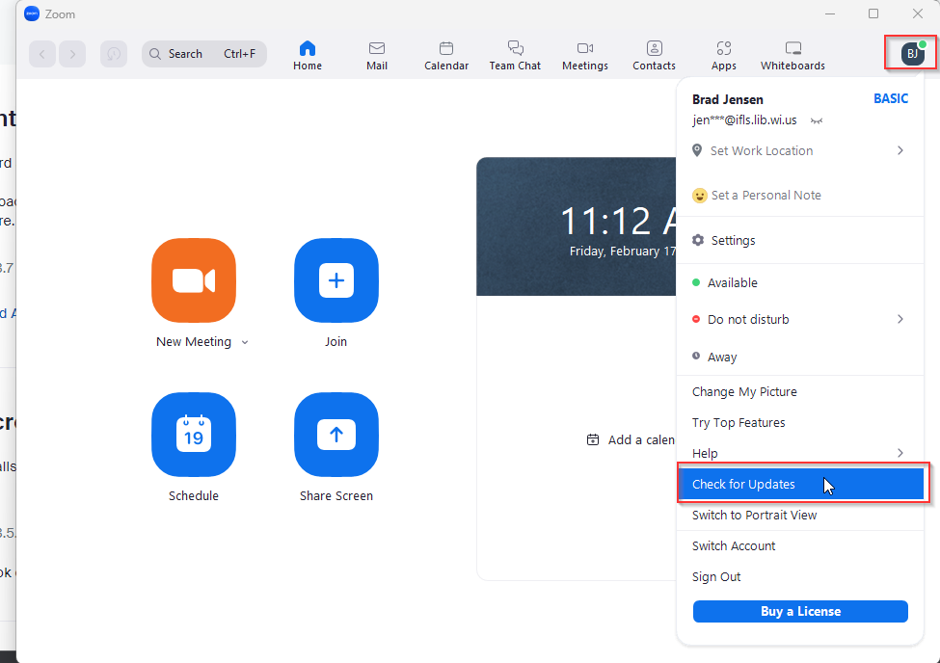
  - After the updates complete (If it finds any) you can try joining the meeting again.
Another Way to Connect:
- Something else you can try is clicking on the join button near the middle of the Zoom application window and inputting the meeting ID manually: 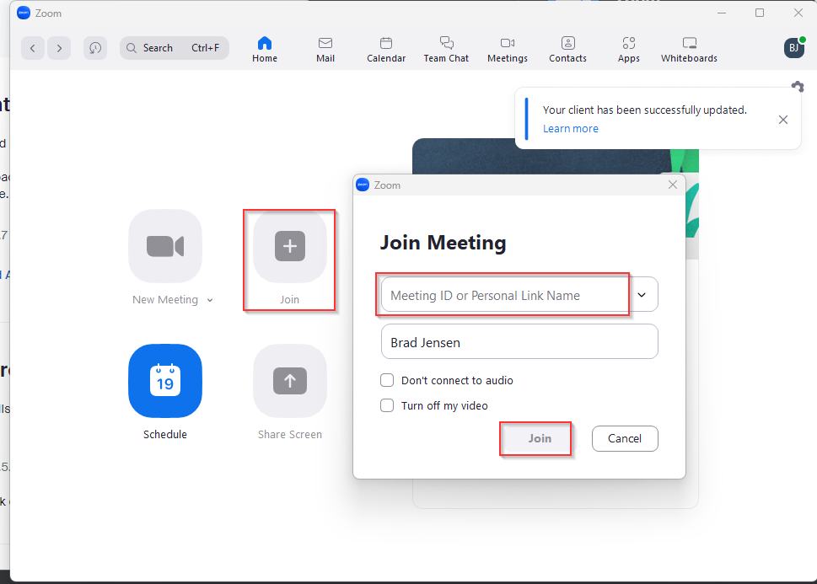
  - The meeting link provided with your meeting packet includes the meeting ID number. Your agenda also contains this information.
    - Note: The meeting password is case sensitive.
Audio Not Working Properly:
Here are some things you can try if either you cannot hear others or if they cannot hear you:
- When you start the meeting, Zoom may have muted you and turned your camera off, if you click on the microphone icon it will mute/unmute you and if you click on the camera icon it will start and stop your webcam. (The red line through the icon means it is disabled.):
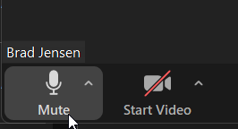

- If you cannot hear the meeting attendees or the meeting attendees are having trouble hearing you, click on the small arrow on the microphone icon and making sure your options under “Select a Microphone” and/or “Select a Speaker” are set appropriately:
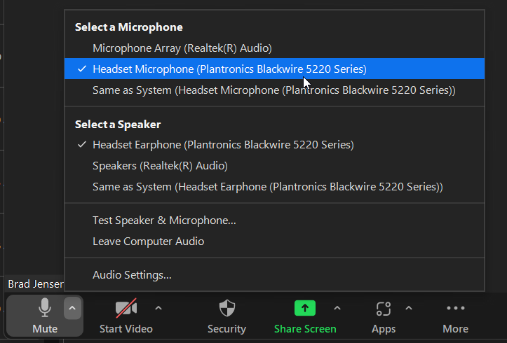

  - If you are not sure what you should select but know that audio is working on other applications on your computer, you may want to try selecting “Same as system” for the microphone and/or speaker depending on what is not working.

  - If you are using a headset, The microphone and speaker would likely need to be set to the same setting if possible. But if you are using headphones without a built-in microphone, just the speakers should be set to that device.

- Check to make sure any external microphone, speakers or headset are fully plugged into the computer. (It may also be worth trying to unplug them completely and plugging them back in.)
Finally: If you are running out of time and not able to connect, there should also be phone-in option information listed in your meeting packet.

